2/9/2023

Nida Ahmed

GLA4 DATA TECHNICIAN BOOTCAMP

Data Visualisation

Assignment 1

Table of Contents

First Task 2

Policies and Procedures 2

Second Task 3

GDP Tasks 3

Set a password to protect the workbook. 3

Highlight column C and change the data to display in British Pound symbol 4

Turn the GDP sheet into a table. 5

Filter the table to display only the information for 2019 6

Next create a chart that will only display the following data ‘Rank, Country and GDP - per 6

capita (PPP). 6

Add a title 7

Add X and Y axis labels 7

Move the chart to a new sheet tab and label with a suitable name 8

Create a sort for the top 20 highest ranking counties 9

Next create a new Bar chart to display the 20 highest ranking countries from your sort. 10

Colour the background by highlighting the area underneath the table as shown below. Find the add a fill colour icon and select a colour. 10

The next task is to create 3 macro buttons, print the sheet, Save the file and Copy the sheet. 11

Third Task 13

Tableau 13

Reflection on Project 14

First Task

## Policies and Procedures

When working with data, there are certain policies and procedures that must be adhered to in order to make sure we are complying with privacy and security laws around usage of data.

The General Data Protection Regulation (GDPR), provides a legal framework for keeping everyone's personal data safe by requiring companies to have robust processes in place for handling and storing personal information.

The Data Protection Act 2018 is the UK’s implementation of the General Data Protection Regulation (GDPR). It protects how personal information is used be organisations, businesses and/or the government.

Everyone responsible for using personal data must follow certain rules in order to ensure they are following GDPR guidelines. The data being worked with must be the following:

* used fairly, lawfully and transparently
* used for specified, explicit purposes
* used in a way that is adequate, relevant and limited to only what is necessary
* accurate and, where necessary, kept up to date
* kept for no longer than is necessary
* handled in a way that ensures appropriate security, including protection against unlawful or unauthorised processing, access, loss, destruction or damage

Further to this, more sensitive information such as the below has stronger legal protection.

* race
* ethnic background
* political opinions
* religious beliefs
* trade union membership
* genetics
* biometrics (where used for identification)
* health
* sex life or orientation

During this assignment, we will be working with data from the Wealth of Nations. Since this data type is open-data, we are free to access, use and share this data set. There is no personal or sensitive information contained.

As a data analyst, it is important to follow policies and procedure on data as working with data includes some risks such as fraud and/or discrimination. Following GDPR guidelines can protect us as individuals and organisations from falling into disputes which can incur financial losses as well as putting our reputation on stake.

# Second Task

## GDP Tasks

## Set a password to protect the workbook.

Steps taken:

REVIEW – PROTECT WORKBOOK – ENTER PASSWORD

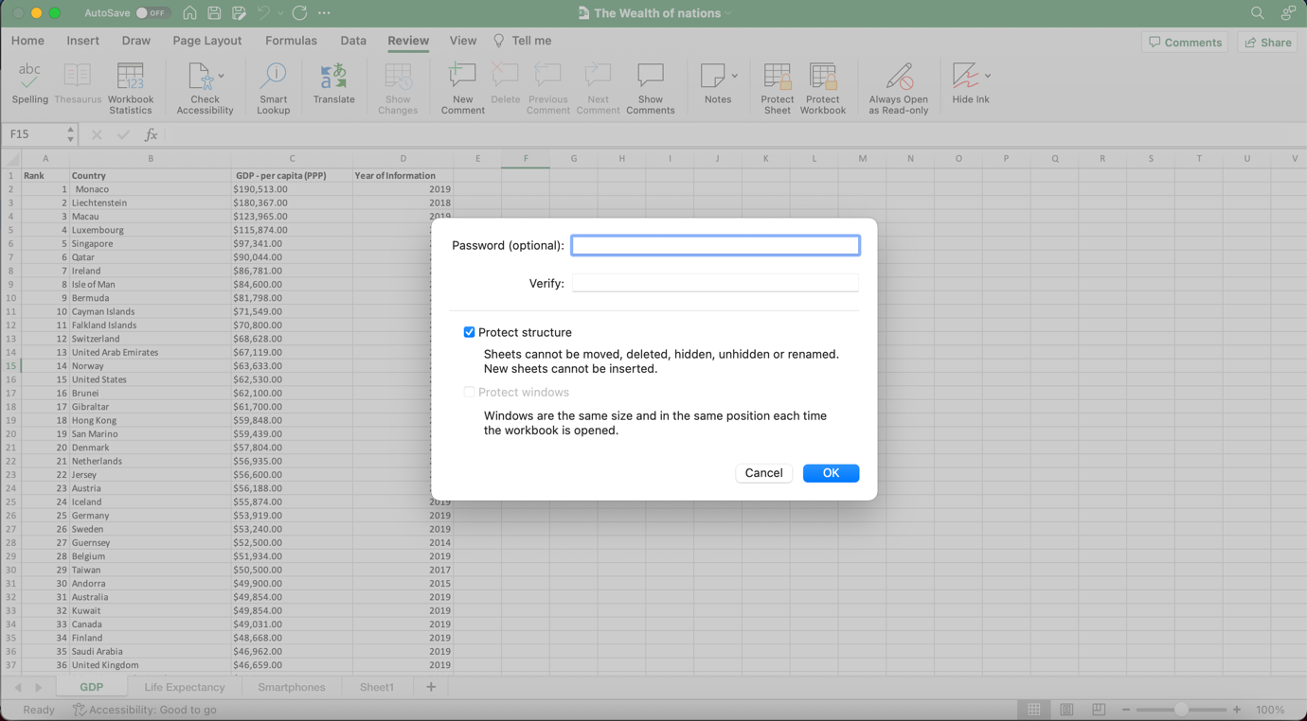

## Highlight column C and change the data to display in British Pound symbol

Steps taken:

HOME – FORMAT – FORMAT CELLS

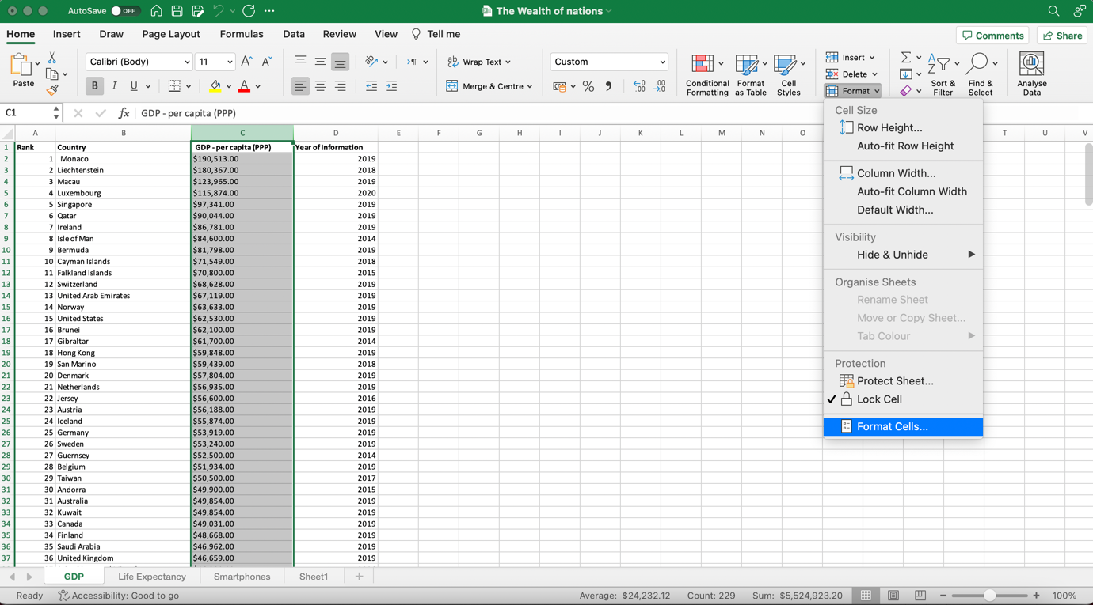

NUMBER – CURRENCY – SELECT £ FROM DROPDOWN

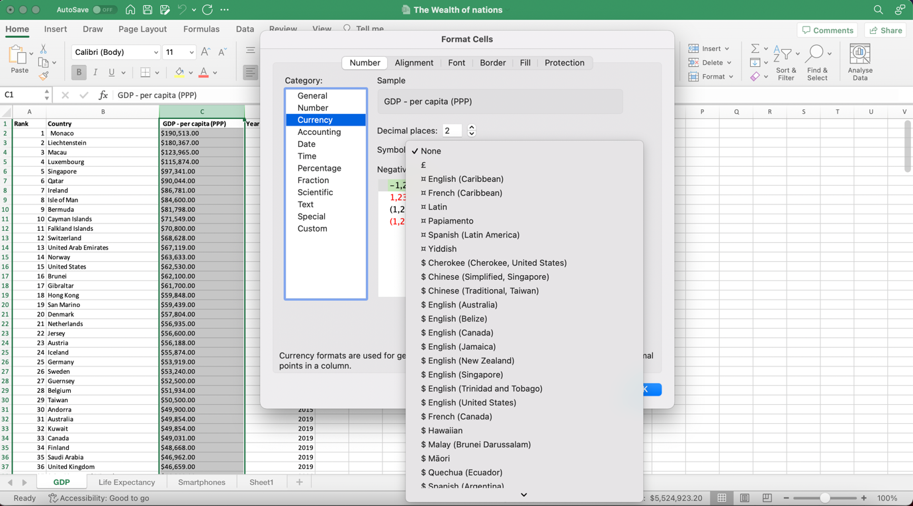

## Turn the GDP sheet into a table.

SELECT RELEVANT CELLS - HOME – FORMAT AS TABLE – SELECT TABLE STYLE – CONFIRM CELLS – OK

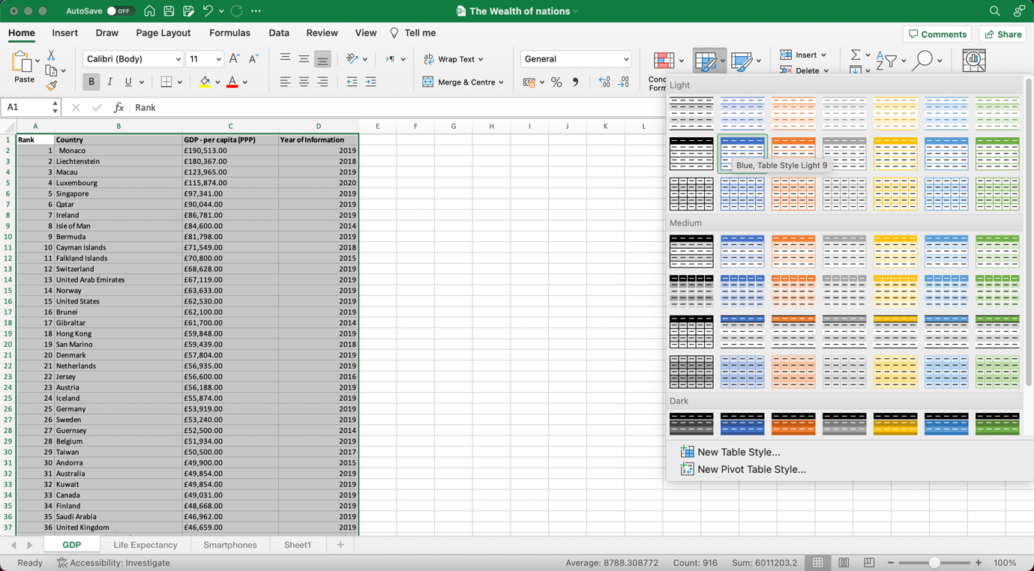

## Filter the table to display only the information for 2019

CLICK ARROW NEXT TO ‘YEAR OF INFORMATION’ – UNSELECT ALL – SELECT ONLY 2019

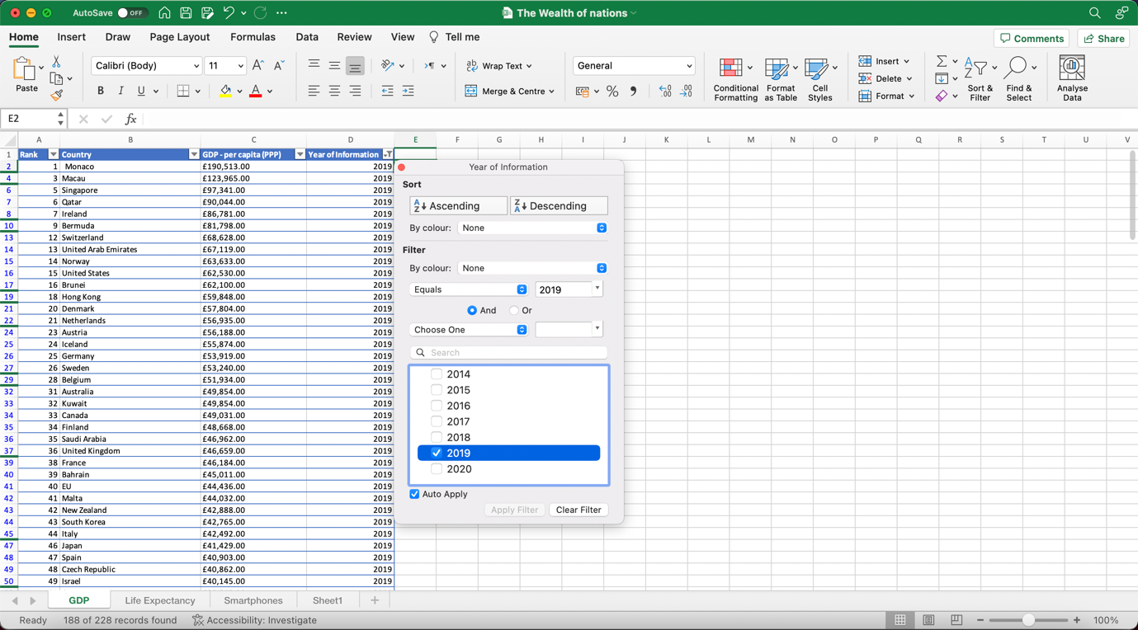

## Next create a chart that will only display the following data ‘Rank, Country and GDP - per

## capita (PPP).

HIGHLIGHT THE REQUIRED COLUMNS – INSERT- CHARTS – SELECT CHART TYPE

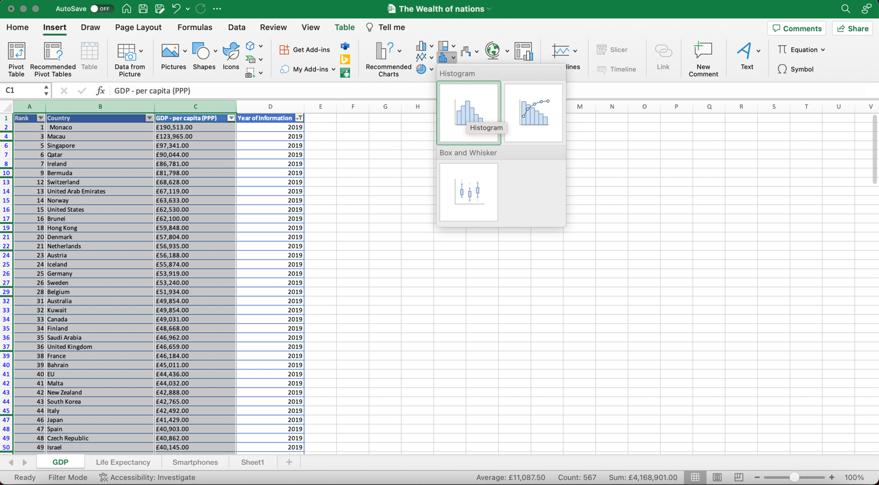

## Add a title

## Add X and Y axis labels

CLICK ON CHART – CHART DESIGN – ADD CHART ELEMENT – SELECT AXIS TITLES FROM DROPDOWN – ADD TITLES

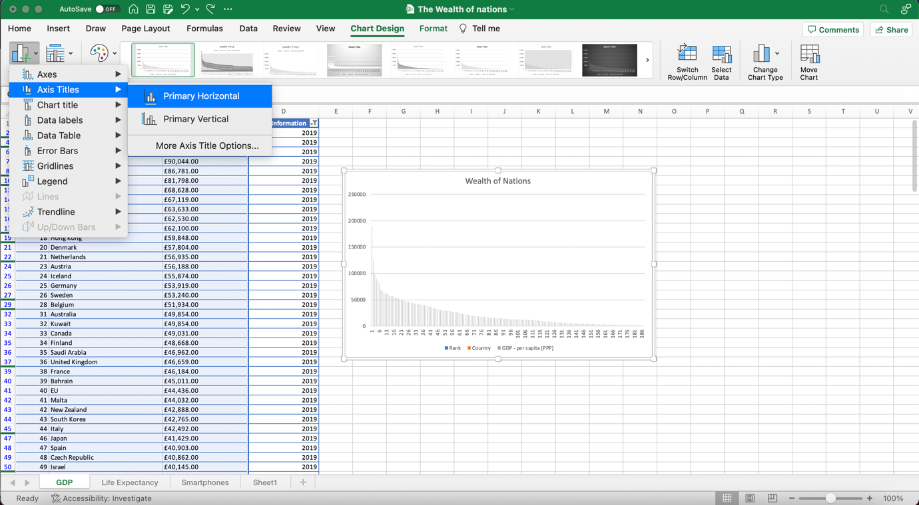

## Move the chart to a new sheet tab and label with a suitable name

CREATE NEW SHEET - UNLOCK WORKBOOK – RENAME SHEET

CLICK ON THE CHART – CHART DESIGN – MOVE CHART

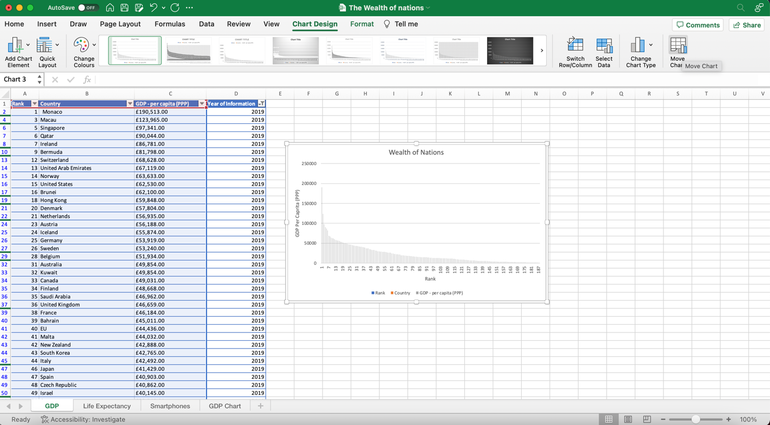

If new sheet was not already created, we can select new sheet and name it here. In this case I followed the below steps:

OBJECT IN – SELECT SHEET NAME - OK

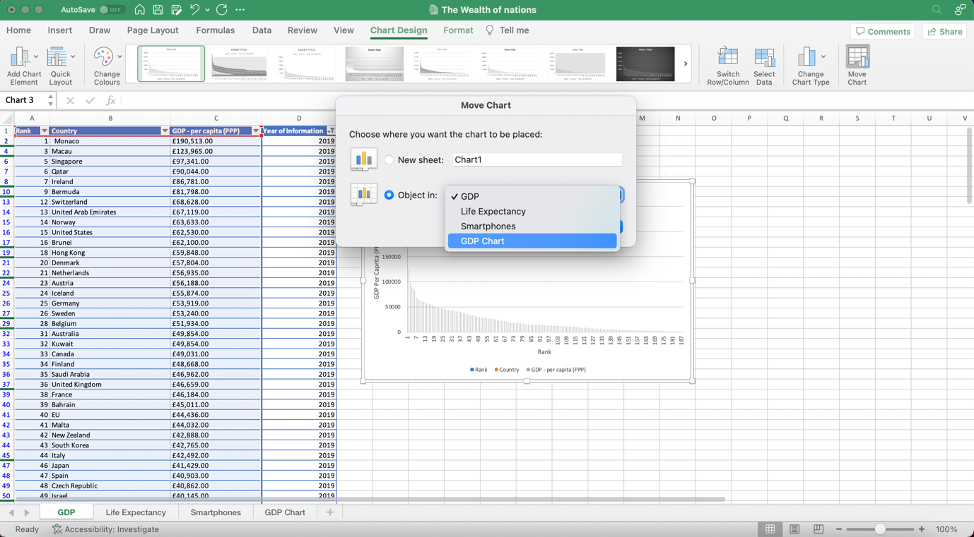

## Create a sort for the top 20 highest ranking counties

SELECT ARROW NEXT TO GDP COLUMN – FILTER – TOP 10 – INCREASE TO 20

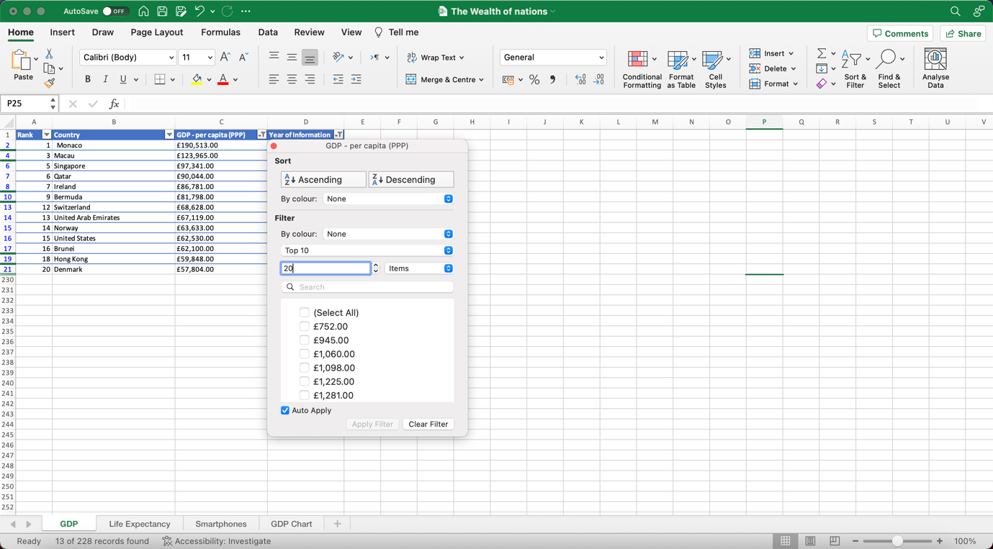

## Next create a new Bar chart to display the 20 highest ranking countries from your sort.

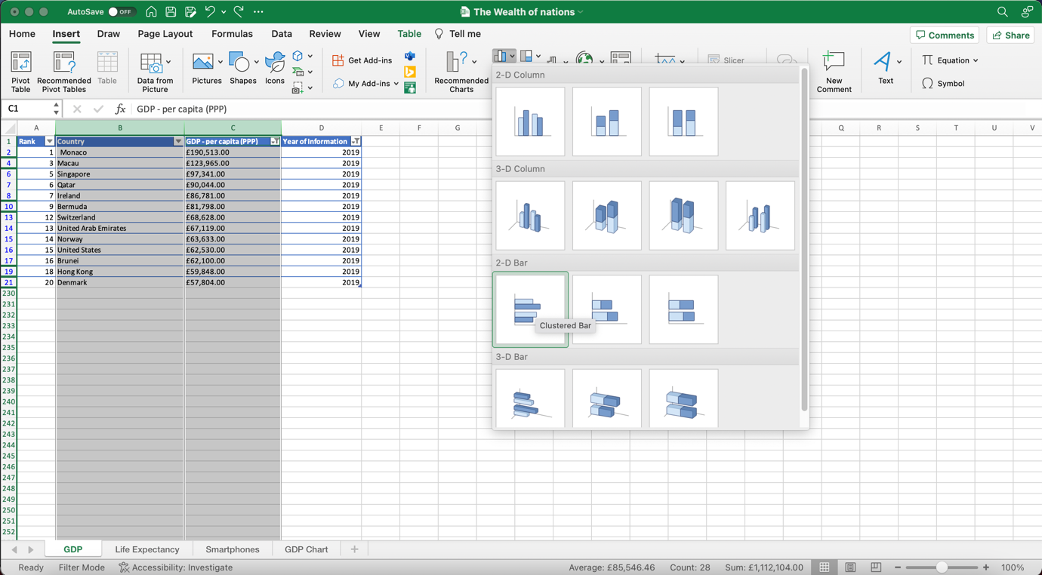SELECT REQUIRED COLUMNS – INSERT – CHARTS – 2D BAR CHART

## Colour the background by highlighting the area underneath the table as shown below. Find the add a fill colour icon and select a colour.

SELECT BACKGROUND CELLS – HOME – FILL COLOUR ICON – SELECT COLOUR

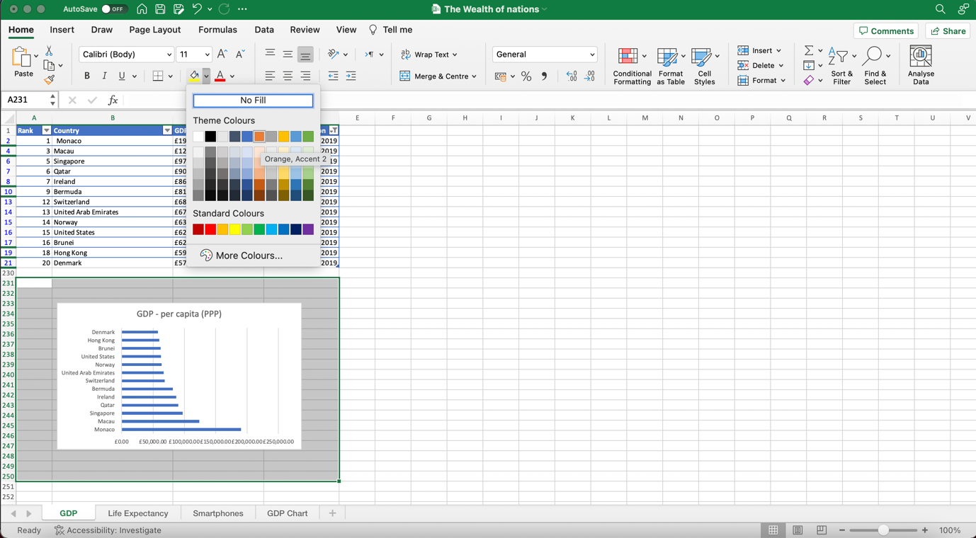

## The next task is to create 3 macro buttons, print the sheet, Save the file and Copy the sheet.

To make the buttons I followed the below steps. I repeated three times using three different shapes.

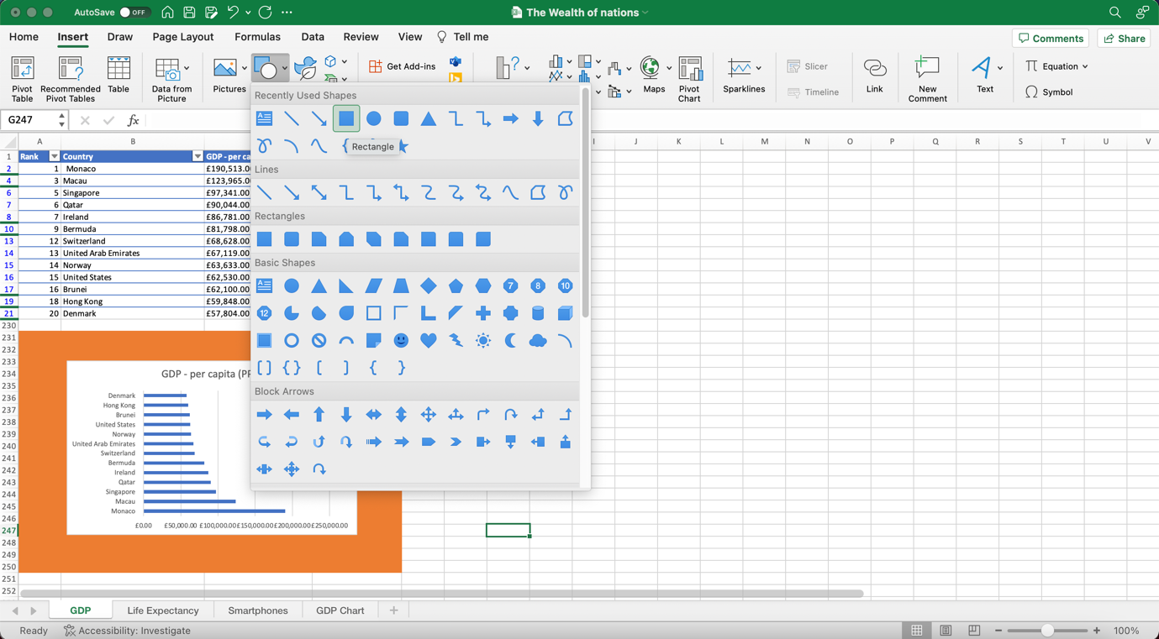

VIEW – RECORD MACRO – FILE - SAVE – MACRO – STOP RECORDING

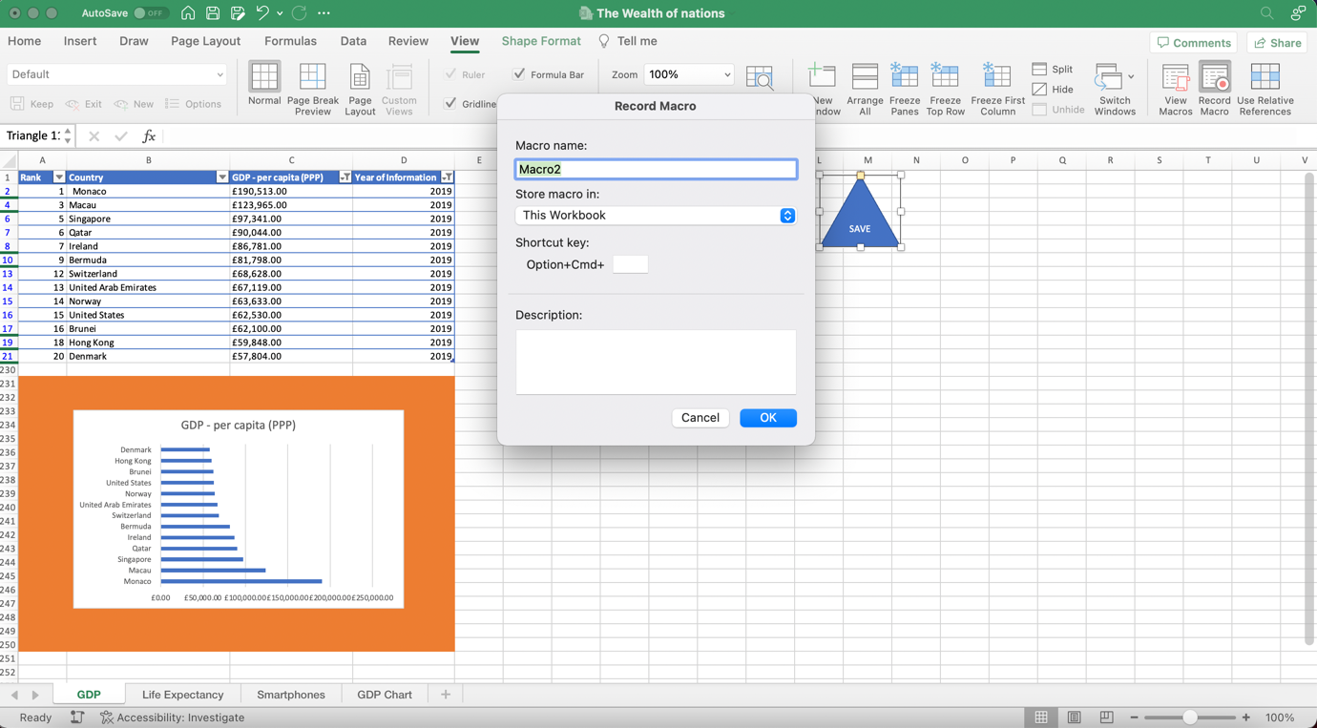

RIGHT CLICK TO SHAPE – ASSIGN MACRO – SELECT MACRO NAME TO BE ASSIGNED

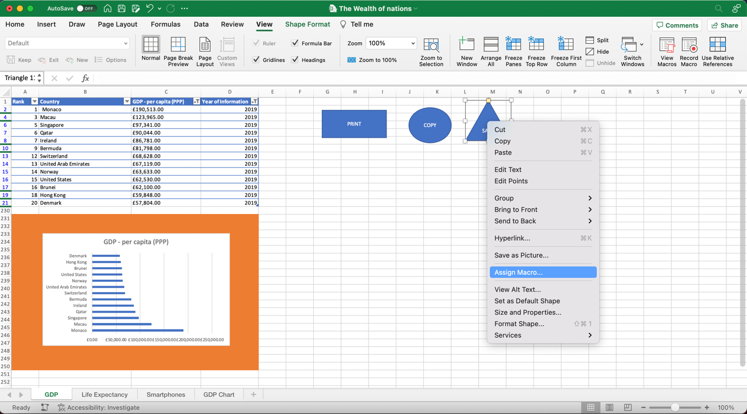

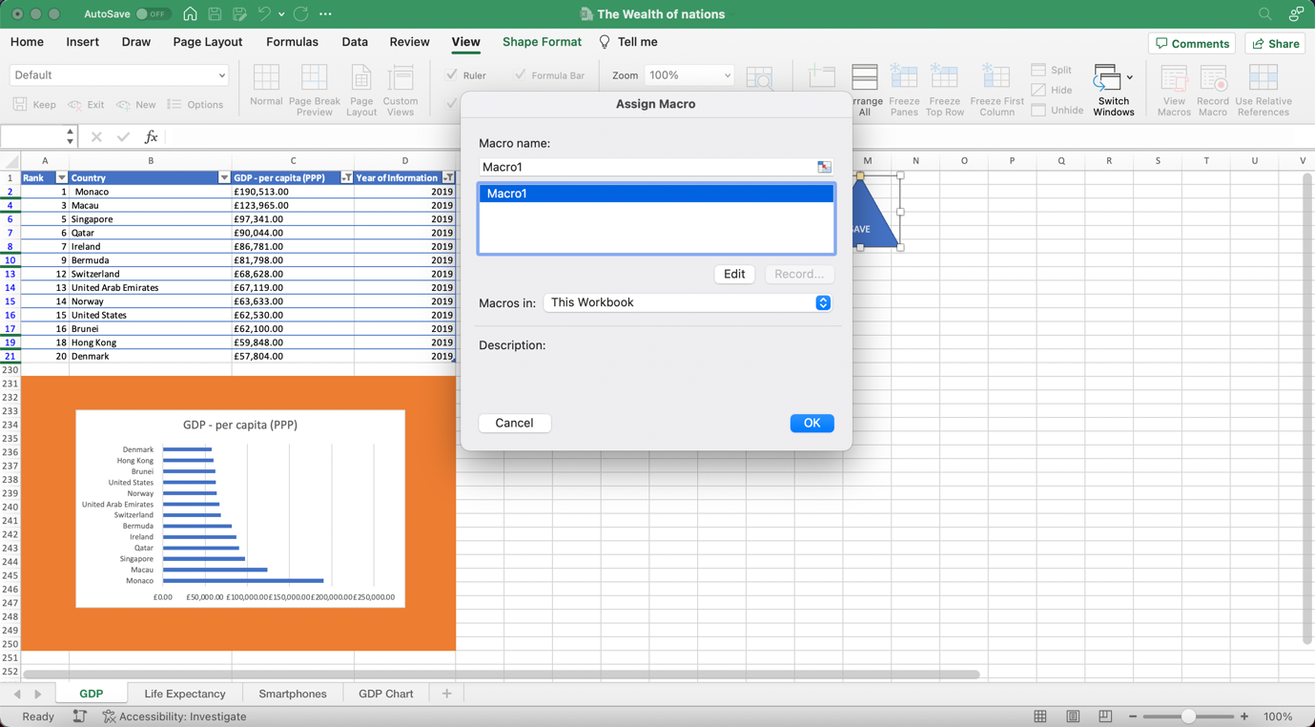

# Third Task

## Tableau

Dashboard 1

<https://public.tableau.com/views/Assignment1-Nida/WONDashboard2?:language=en-GB&publish=yes&:display_count=n&:origin=viz_share_link>

Dashboard 2

<https://public.tableau.com/views/Assignment1-Nida-Dashboard2/WONDashboard1?:language=en-GB&publish=yes&:display_count=n&:origin=viz_share_link>

# Reflection on Project

I have thoroughly enjoyed completing this first assignment. Unfortunately, I had missed week 3 and 4 of the technical workshops which meant I was behind on the work. I caught up in my own time and have found the videos very helpful to catch up and experiment with Tableau.

I enjoyed using my own initiative and finding instructions through youtube or simple google searches where I could not remember how to perform a particular task.

The lesson recordings helped a great deal for me to follow along to learn the purpose and basics of Tableau. I still have a long way to go and definitely need to play around more on Tableau to work out the endless options of dashboard in order to tell a story.